Joint Workshop
EU-made cybersecurity for safe, resilient and trustworthy applications and services

27 February 2023 | 9:00 – 13:00 CET | online

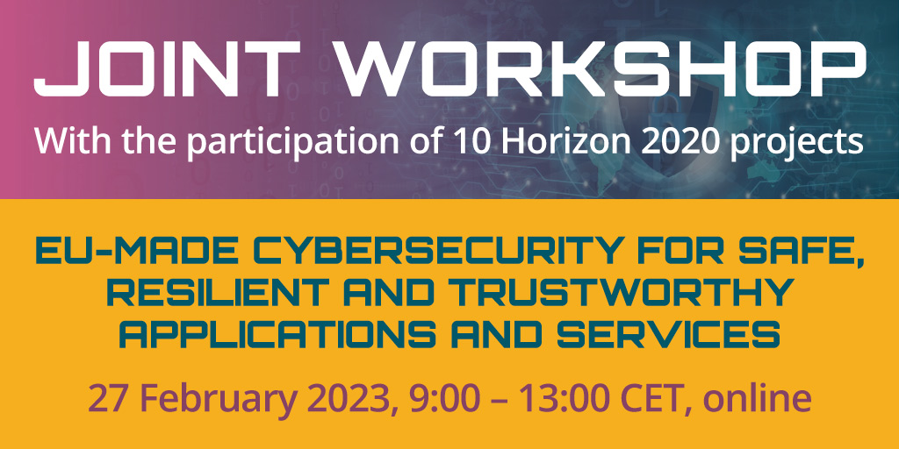

In recent years, the development and increasing adoption of a large variety of Internet of Things (IoT) technologies, devices and solutions have disrupted many industries and modified many aspects of our everyday life, generating a huge impact on businesses, consumers and governments. This has huge implications regarding security and privacy. New technologies will tend to further intensify cybersecurity issues and put in evidence the need for trust and secure solutions for current and future digital services powered by IoT systems.

The European Commission selected several project that directly address the cybersecurity needs of EU industry and public. Each project has concrete applications which focus on different verticals/application domains: education, energy, healthcare, manufacturing mobility, 5G and 6G networks, emergency and vigilance or smart cities.

This workshop, jointly organised by ARCADIAN-IoT, ELECTRON, ERATOSTHENES, IDUNN, IRIS, KRAKEN, SECANT, SENTINEL, SPATIAL, TRUST aWARE projects, will provide an overview on how novel solutions can protect the complex ICT infrastructures and create a stronger, more innovative and resilient European industry.

The EU-made cybersecurity workshop is designed to provide attendees with the knowledge to create safe, resilient, and trustworthy applications and services. The online workshop will cover a range of topics related to cybersecurity, including:
- Best practices for designing and building secure applications and services
- Techniques for identifying and mitigating cybersecurity risks
- Strategies for ensuring the resilience of applications and services in the face of cyber threats

Agenda:

Start | End | Time | Session | Presenter
09:00 | 09:05 | 5’ | Welcome and introduction | TBD
09:05 | 09:20 | 15’ | KEYNOTE presentation | TBD
09:20 | 09:40 | 20’ | 5G & 6G  SPATIAL Project | Madhusanka Liyanage, Assistant Professor/ Ad Astra Fellow
09:40 | 10:00 | 20’ | EDUCATION  KRAKEN Project | TBD
10:00 | 10:20 | 20’ | EMERGENCY AND VIGILANCE  ARCADIAN-IoT | TBD
10:20 | 10:40 | 20’ | ENERGY  ELECTRON Project | TBD
10:40 | 11:00 | 20’ | HEALTHCARE  SECANT Project | TBD
11:00 | 11:20 | 20’ | MANUFACTURING/INDUSTRY  IDUNN Project | TBD
11:20 | 11:40 | 20’ | MOBILITY  ERATOSTHENES Project | TBD
11:40 | 12:20 | 40’ | Security and privacy (S&P) threats  TRUST AWARE Project  SENTINEL Project | Javier Gutierrez and Angel Sola Lopez (TRUST aWARE)
12:20 | 12:40 | 20’ | SMART CITIES  IRIS Project | Susana Gonzalez Zarzosa and Rodrigo Diaz Rodriguez, ATOS
12:40 | 12:50 | 10’ | Q&A
12:50 | 13:00 | 10’ | Conclusions

REGISTRATION LINK:
https://www.eventbrite.com/e/eu-made-cybersecurity-for-safe-resilient-and-trustworthy-applications-tickets-522586308717

